

**THE UNIVERSITY OF THE WEST INDIES**

**Mona Campus**

Semester l Semester II □ Supplemental/Summer School □

**Mid-Semester Examinations of: October /February/March** □ **/June** □ **2014/2015**

Course Code and Title: **COMP2201 Discrete Mathematics for Computer Scientists**

Date: **Friday, October 31, 2014** Time: **2:00 p.m.**

Duration: **1 Hour.** Paper No: **1 (of 1)**

Materials required:

**Answer booklet: Normal Special** □ **Not required** □

**Calculator: Programmable** □ **Non Programmable Not required** □

*(where applicable*)

**Multiple Choice answer sheets: numerical □ alphabetical □ 1-20 □ 1-100** □

Auxiliary/Other material(s) – Please specify: None

**Candidates are permitted to bring the following items to their desks: Pencil or pen, Ruler, ID card, Exam card**

**Instructions to Candidates: This paper has 2 pages & 6 questions.**

**Candidates are reminded that the examiners shall take into account the proper use of the English Language in determining the mark for each response.**

# All questions are COMPULSORY.

**Calculators are allowed.**

**MID-SEMESTER 1 2014/2015**

2

1. (a) Write the formula to find the number of integer solutions of

*x*1 + *x* 2 + *x* 3 + *x* 4 = 16

subject to *x* 1 ≥ 1, *x* 2 > 0, *x* 3 ≥ 2, *x*4 ≥ 4 **[1]**

**8+4-1C4-1**

(b) By using the inclusion-exclusion principle, give a formula for the

number of elements in the union of four sets *X1*, *X2*, *X3* and *X4*. **[2]**

**TODO: Change A B C D to X1 X2 X3 X4 lol**

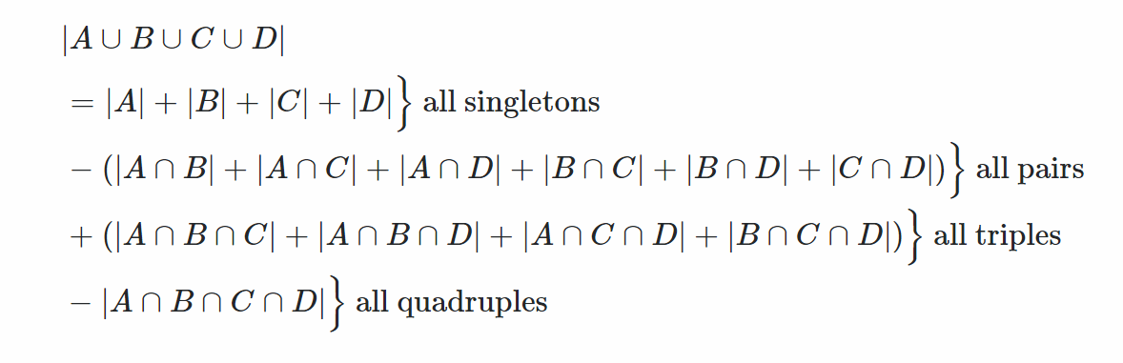

**.**

**=**

**-**

**+**

**-**

1. (a) Use the Binomial Theorem to show that

*n*

4*n**k C*(*n*, *k* )  5*n*

*k* 0

We know that ${\left(a+b\right)}^{n}=\sum_{k=0}^{n}{C\left(n,k\right){a^{n-k}b}^{k}}$

We eliminate bk and substitute values for the proof

Let a = 4, b = 1

So we have,

. $\sum_{k=0}^{n}{C\left(n,k\right){a^{n-k}b}^{k}}={\left(a+b\right)}^{n}$

. $\sum_{k=0}^{n}{C\left(n,k\right){4^{n-k}1}^{k}}={\left(4+1\right)}^{n}$

As 1x = 1 for x $∈Z$

Therefore,

. $\sum_{k=0}^{n}{4^{n-k}C\left(n,k\right)}=5^{n}$

(b) Use Pascal’s triangle to compute the values of

# [3]

 7

 7

  

*and*

  

 4

5

**[2]**

. $\left({7 \atop 4}\right)$ = $\frac{7!}{4!\left(7-4\right)!}$

= $\frac{5040}{144}$

= 35

. $\left({7 \atop 5}\right)$ = $\frac{7!}{5!\left(7-5\right)!}$

= $\frac{5040}{240}$

= 21

1. Consider the recurrence function

*T(n) = 27T(n/3) + 56n3*

Give an expression for the runtime *T(n)* if the recurrence can be solved

with the Master Theorem. Assume that *T(n) = 1* for *n ≤ 1*. **[4]**

1. (a) In a given university only 3 percent of all graduates will register for the university’s alumni association. Find the probability that among 200 graduates in that university at least three will register for the university’s alumni association. **[3]**

Using Binomial

. $b\left(x;n,θ\right)=C_{x}^{n} θ^{x}({1-θ)}^{n-x}$ for x = 0,1,2,…,n

. $b\left(3;200,0.03\right)=C_{3}^{200} ×{0.03}^{3}×{0.97}^{200-3}$

. $=0.0879$

(b) If a student does not study at all for this COMP2201 Mid-term examination, the probability of passing the examination is 3%. If one studies at an average level, the probability of passing the examination is 51% whereas if study is done intensely, the probability of passing the COMP2201 Mid-term examination is 92%. The course lecturer is sure that 8% of students do not study at all, 67% of them study at an average level and 25% of them study intensely.

1. What is the probability of a student passing this COMP2201 Mid-term examination? **[3]**

**Let**

**N - Study None at all**

**L - Study at Average Level/ Studied Lightly**

**I - Studied Intensely**

**C - Passing the course COMP2201**

**Given**

**P(C|N) = 0.03**

**P(C|L) = 0.51**

**P(C|I) = 0.92**

**P(N) = 0.08**

**P(L) = 0.67**

**P(I) = 0.25**

**Required P(C)**

**P(C) = $P(C|N)P(N)+ P(C|L)P(L) + P(C|I)P(I)$**

**= $\left(0.03\right)\left(0.08\right)+ \left(0.51\right)\left(0.67\right) + \left(0.92\right)\left(0.25\right)$**

**= $0.0024+ 0.3417 + 0.23$**

***= 0.5741***

1. Draw the Probability Tree that represents the given scenario? **[3]**

**Prior Probabilities Conditional Probabilities Joint Probabilities**

**P(C|N) = 0.03 P(C∩N) = (0.03)(0.08) = 0.0024**

**P(|N) = 0.97 P($\overline{C}$ ∩N) = (0.97)(0.08) = 0.0776**

**P(N) = 0.08**

**P(C|L) = 0.51 P(C∩L) = (0.51)(0.67) = 0.3417**

**P(L) = 0.67**

**P(|L) = 0.49 P($\overline{C}$ ∩L) = (0.49)(0.67) = 0.3283**

**P(I) = 0.25 P(C|I) = 0.92 P(C∩I) = (0.92)(0.25) = 0.23**

**P(|I) = 0.08 P($\overline{C}$ ∩I) = (0.08)(0.25) = 0.02**

1. Show that *2n + 4n + 6n + 8n + … + (n-2)n + n2* is of order *n3*. **[4]**

2n + 4n + 6n + 8n + … + (n-2)n + n2 ≤ n2 + n2 + n2 + n2 + … + n2

≤ n * n2

≤ n3

For all n ≥ 1.

Therefore 2n + 4n + 6n + 8n + … + (n-2)n + n2 = O(n3)

We may obtain a lower bound by examining the full series in relation to a portion of the series:

2n + 4n + 6n + 8n + … + (n-2)n + n2

≥

≥

≥

≥

≥

Hence,

2n + 4n + 6n + 8n + … + (n-2)n + n2 = Ω(n3)

Therefore,

2n + 4n + 6n + 8n + … + (n-2)n + n2 = Θ(n3)

1. In an arithmetic series, the sum of the second term and the sixth term is 29. Three consecutive terms of the same series are 4*x* – 11, 3*x* – 2 and 4*x* – 4. If the sum of the terms in the series is 130
   1. Find *x* **[1]**
   2. Find the common difference, d **[1]**
   3. Find the first term, a **[1]**
   4. Find the number of terms in the series, n **[2]**

For AP, the difference between consecutive terms is the common difference, d

Therefore

d = (3x - 2) – (4x - 11)

= -x + 9

Also

d = (4x - 4) – (3x - 2)

= x - 2

Equating

d = -x + 9 = x - 2

⇒ 2x = 11

x = 11/2

Using x as 11/2 to solve for d we have,

d = -x + 9

= -(11/2) + 9

= 3.5

Therefore the common difference d, between the terms 3.5

u2 = a + d un = a + (n-1)d

u6 = a + 5d

u2 + u6 = 29

⇒  a + d + a + 5d = 29

⇒ 2a + 6d = 29

⇒ 2a + 6(3.5) = 29

⇒ 2a = (29 – 6(3.5))

⇒ 2a = (29 – 21)

⇒ a = 8/2

⇒ a = 4

Therefore the first term a, is 4

Sn = (n/2)(2a + (n-1)d)

130 = (n/2)(2(4) + (n-1)(3.5))

130 = (n/2)(8 + 3.5n - 3.5)

260 = n(4.5 + 3.5n)

260 = 4.5n + 3.5n^2

2600 = 45n + 35n^2

45n + 35n^2 – 2600 = 0

Factoring Quadratic Equation

45n + 35n^2 – 2600 = 0

5(9n + 7n^2 - 520) = 0

5((7n^2 + 65n) (-56n-520)) = 0

5(n(7n + 65) -8(7n + 65)) = 0

5(n - 8)(7n + 65) = 0

Either (n – 8) = 0 or (7n + 65) = 0

n – 8 = 0

n = 8

Or

7n + 65 = 0

7n = -65

n = -65/7

Since n has to be in the set of natural numbers then n must be equal to 8

Therefore the number of terms in the series n, is 8

# END OF QUESTION PAPER

**Mid-Semester I 2014/2015**